Homework Project
As part of the topic Frozen Kingdom, children in Y5 will be learning about animals from the Arctic.
For their homework project this term, we would like to children to design a sculpture of their favourite Arctic animal.
You can design or make your model from whatever materials you wish. For example, you might want to make it out of recyclable materials or clay or even wood, but try to be creative as you can!
The deadline for this homework is: 22nd November 2017

Below are some pictures to help you get started
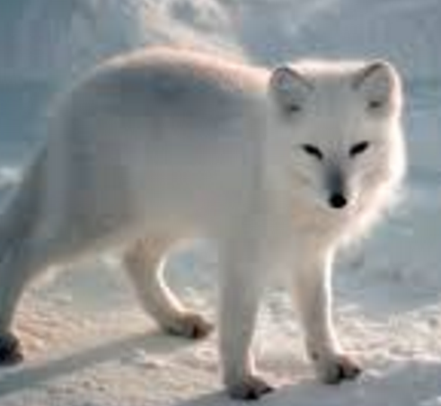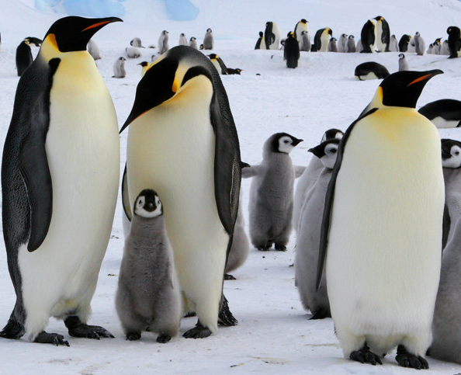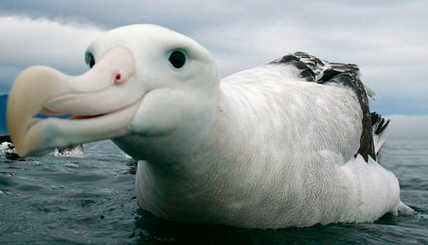

Below is a brief outline of what your child will be learning during this half term
Parent/Carer Information Frozen Kingdom
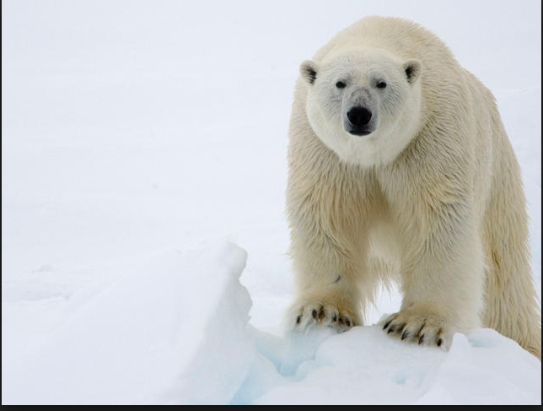
Mrs Metcalfe, Miss McMaster & Miss Ramshaw
Autumn Term 1 2017 Year 5
Literacy
- Setting Description
- Report
- Haiku
- Diaries.
- Spelling, punctuation and grammar.
- Reciprocal reading

Numeracy
- Read, write, compare and order numbers up to 1 000 000;
- Read Roman numerals to 1000;
- Read, write and interpret negative numbers
- Count forwards, backwards in steps of powers of 10.
- Multiply and divide numbers mentally.
- Recognise and use square and cube numbers.
- Identify factors and multiples, know and use prime numbers.
- Add and subtract numbers mentally.
- Formal addition and subtraction up to 4d.
- Solve addition and subtraction multi-step problems in context.
- Formal multiplication up to 4d x 1d.
Music
- Guitar lessons.
Physical Education
- Basketball
Science- Living things and their habitats.
- Recognise how animals have adapted to their surroundings. (Arctic and Antarctic).
- Create food chains and food webs of animals that live in the Antarctic and Arctic).
- Create branching tree diagrams of sea creatures from the Arctic Ocean.
Things to remember:
- PE Monday and Tuesday – PE kit to be kept in school all week (outdoor kit will be required)
- Guitars- Wednesday
- Learn multiplication and division facts.
- Spellings - sent home on Friday to be learnt for test on the following Friday
- Please listen to your child read 3 times per week. Reading records back on Friday please and remember to try to complete your ‘Book Bingo’ card.

History
- Find out what the conditions were like aboard the unsinkable Titanic.
- Describing how the accommodation differed for rich and poor passengers aboard the Titanic and write a wireless telegraph to someone at home describing their experiences, hopes and fears.
- Research the history and development of polar exploration using the internet.
- Create a timeline of polar exploration including key explorers

Geography
- Identifying the different polar-regions.
- Looking at the habitat of animals that live in these regions.
- Investigating the climate and what effect changes to the climate can have.

Frozen Kingdom 