**Homework Project**

[](https://www.google.com/url?sa=i&rct=j&q=&esrc=s&source=images&cd=&cad=rja&uact=8&ved=0ahUKEwjhp--37J3ZAhUD1RQKHUSiDvkQjRwIBw&url=https://ekoh.org.uk/&psig=AOvVaw31-IayOby6UPyBh496yZ_8&ust=1518437929678328)[](https://www.google.com/url?sa=i&rct=j&q=&esrc=s&source=images&cd=&cad=rja&uact=8&ved=0ahUKEwiPm4eq7J3ZAhUDUhQKHZ2LAfcQjRwIBw&url=https://www.slideshare.net/shimha1/famous-artists-13661014&psig=AOvVaw31-IayOby6UPyBh496yZ_8&ust=1518437929678328)

[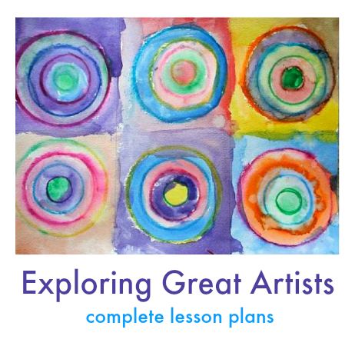](https://www.google.com/url?sa=i&rct=j&q=&esrc=s&source=images&cd=&cad=rja&uact=8&ved=0ahUKEwiOuKLK7J3ZAhXEbhQKHdYOBtMQjRwIBw&url=https://www.pinterest.com/pin/440438038540562053/&psig=AOvVaw31-IayOby6UPyBh496yZ_8&ust=1518437929678328)

**Create your own original piece of artwork inspired by an artist you admire.**

**This can be handed in on Monday 5th March 2018.**

**Parent/Carer Information**

[](http://www.google.com/url?sa=i&rct=j&q=&esrc=s&source=images&cd=&cad=rja&uact=8&ved=0ahUKEwiCyPqO6p3ZAhWBNBQKHY47ASQQjRwIBw&url=http://ayresomeprimary.co.uk/newsletter/year-2-newsletter-spring-1-muck-mess-mixtures/&psig=AOvVaw0BaV9G23_Ltb3x6Yqoe_ue&ust=1518437358306281)

Year 1 & 2

Miss Jackson, Miss Berry & Miss Norton

February 2018

**Below is a brief outline of what your child will be learning during this half term**

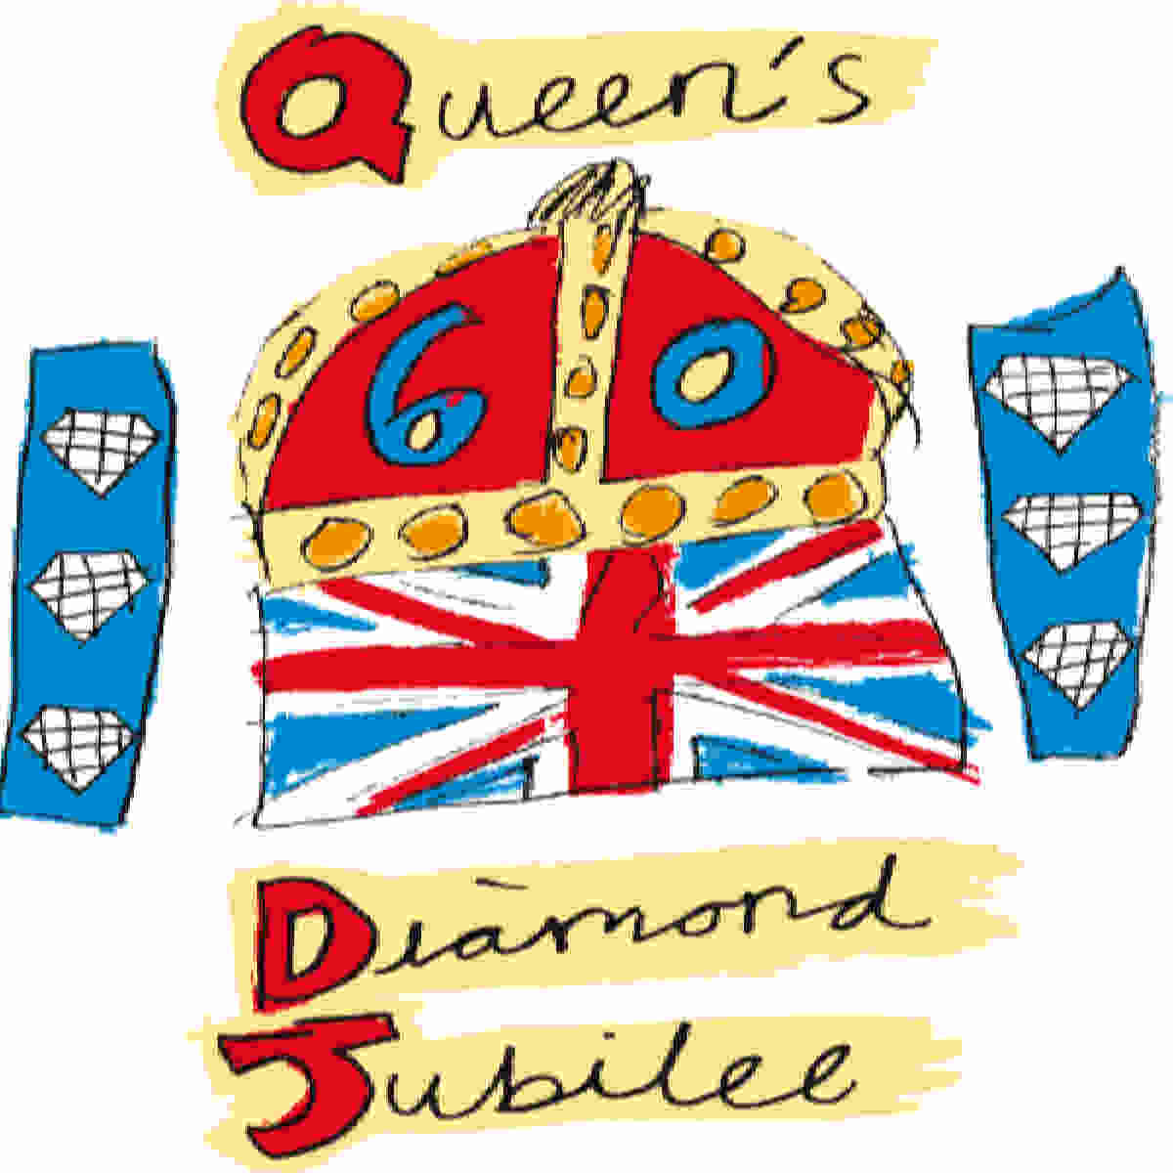

**Literacy**

**Narratives**

* **Stories by the same author**
* **Character description**

**Non-Fiction**

* **Invitations**
* **Instructions**

**Science**

* **Predicting, testing and observing**
* **Mixing different substances together**
* **Melting experiments**

**Muck, Mess and Mixtures**

[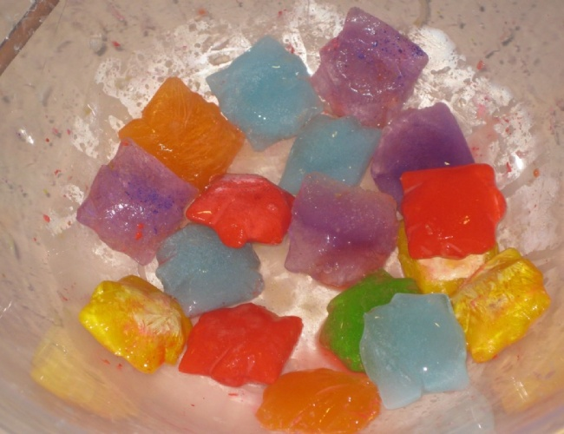](http://www.google.com/url?sa=i&rct=j&q=&esrc=s&source=images&cd=&cad=rja&uact=8&ved=0ahUKEwiW-J6x7p3ZAhVL7BQKHfpkA68QjRwIBw&url=http://www.phoenix.coventry.sch.uk/blog/?pid%3D5%26nid%3D16&psig=AOvVaw2j0v6PAjwWAFvCeoiY8ukI&ust=1518438497994430)

**Art**

* **Painting**
* **techniques with different brushes**
* **Making shades lighter**
* **Recreating the work of a famous artist**
* **Clay models**

**Things to remember!!!**

* **Read at home at least three times weekly – bring reading record every Friday.**
* **Practise for weekly spelling tests**
* **Bring your PE kits every week**
* **Keep checking and contributing to class blogs**

**PE**

* **Games activities**

**Maths**

* **Multiplication – 2, 3, 5, 10**
* **Time**
* **Division**
* **Length, height, weight and capacity**

**D.T**

* **Healthy eating**
* **Making ice cream**
* **Making jelly**