**Homework Project**

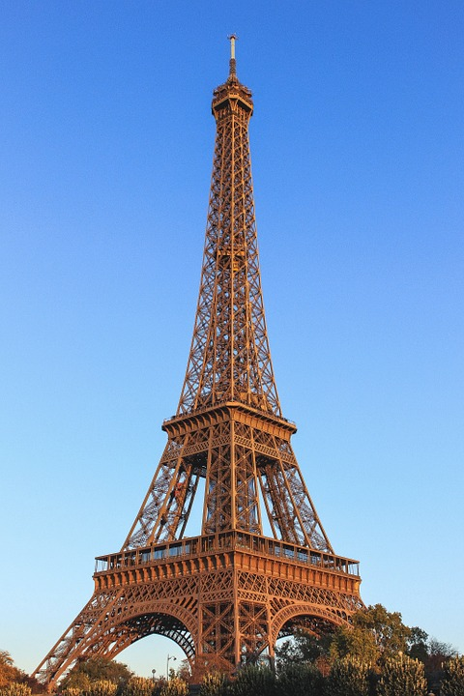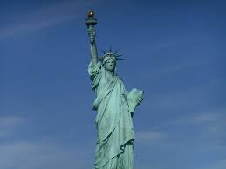

**Create a model or picture of a famous monument from a city of your choice.**

**This can be handed in on Tuesday 8th May 2018.**

**Parent/Carer Information**

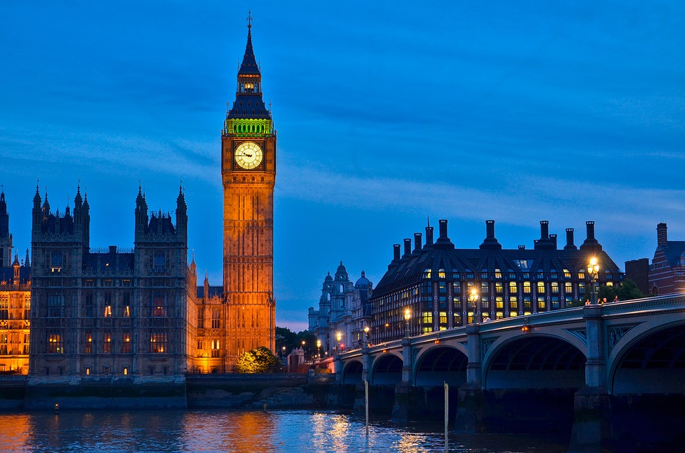[](http://www.google.com/url?sa=i&rct=j&q=&esrc=s&source=images&cd=&cad=rja&uact=8&ved=0ahUKEwiCyPqO6p3ZAhWBNBQKHY47ASQQjRwIBw&url=http://ayresomeprimary.co.uk/newsletter/year-2-newsletter-spring-1-muck-mess-mixtures/&psig=AOvVaw0BaV9G23_Ltb3x6Yqoe_ue&ust=1518437358306281)

Year 1 & 2

Miss Jackson, Miss Berry & Miss Norton

April 2018

**Below is a brief outline of what your child will be learning during this half term**

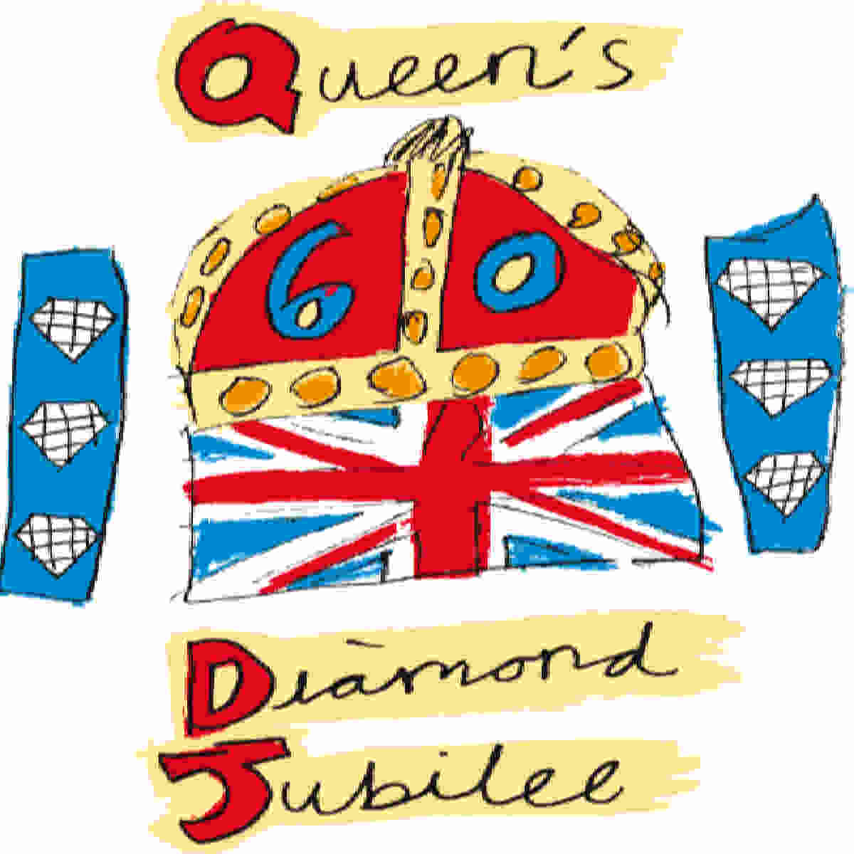

**Literacy**

**Narratives**

* **Stories – Paddington’s Trips**

**Non-Fiction**

* **Information Leaflet about London**
* **Recount about the Great Fire of London**

**Science**

* **Everyday materials**
* **Properties of materials**
* **Testing/experimenting with materials and properties**

**Bright Lights, Big City**



**History**

* **London – past and present**
* **Life in the 17th century**
* **Great Fire of London**

**Things to remember!!!**

* **Read at home at least four times weekly – bring reading record every Friday.**
* **Practise for weekly spelling tests**
* **Bring your PE kits every week**
* **Keep checking and contributing to class blogs**

**PE**

* **Athletics**

**Maths**

* **Multiplication – 2, 3, 5, 10**
* **Addition**
* **Division**

**Geography**

* **4 countries of the UK**
* **Positional geographical language – compass work**
* **Map skills**
* **Capital cities**